Day 3 Internship Task
Understanding LLMs, Tokens and Context Windows

1. Review: Generative AI and LLMs
Generative AI is a type of artificial intelligence that learns patterns from existing data and uses them to create new content, such as text, images, or code. A Large Language Model (LLM) is a Generative AI model trained on very large amounts of text. It can answer questions, summarize content, help with coding, and follow instructions by predicting what text should come next, one piece at a time. GPT, Gemini, and Claude are common examples.

2. What Are Tokens?
An LLM does not read text the way people do. It splits the text into small pieces called tokens and processes those. A token can be a whole word, part of a word, a punctuation mark, or even a space. This means one word is not always one token. A short, common word like “cat” is usually a single token, while a longer or rarer word may be split into several tokens. For example, “unbelievable!” could be broken into pieces such as “un”, “believ”, “able”, and “!”. The exact split depends on the model.

3. Why Tokens Matter
- API cost: most AI APIs charge based on the number of tokens sent to the model and the number it generates.
- Processing limits: a model can only handle a limited number of tokens in one request.
- Amount of information: the token limit decides how much text, such as instructions, documents, or conversation history, can be given to the model at once.

4. What Is a Context Window?
The context window is the maximum number of tokens a model can work with in a single request or conversation. It covers everything the model sees: the instructions, the earlier messages, any documents provided, and the response it is generating. If the content is longer than the window, parts of it cannot be processed, so the model may lose earlier details.
This becomes important in three situations. With long documents, a whole file may not fit in one request. With long conversations, older messages can fall outside the window. With RAG applications, only the most relevant pieces of a large document can be sent to the model, which is why techniques like chunking and embeddings are used.

5. Input and Output
The input is everything sent to the model, such as the user’s question, instructions, and extra context. The output is the response the model generates. From a developer’s point of view, an application sends an input to the model through an API and then receives the output to show to the user. Both input and output count toward the token usage, so the length of each affects cost and the context window.

6. Basic LLM Limitations
- Incorrect information: the model can state wrong facts with confidence.
- Misunderstood instructions: unclear or complicated prompts may not be followed as intended.
- Inconsistent answers: asking the same question again can give a different answer.
- Hallucinations: the model may invent details, sources, or facts that do not exist.
Because of these limits, important answers should always be checked against reliable sources.

7. Practical Experiment: Changing the Instructions
Question: What is a context window in an LLM?
Prompt A: “Explain what a context window is in an LLM to a software engineer.”
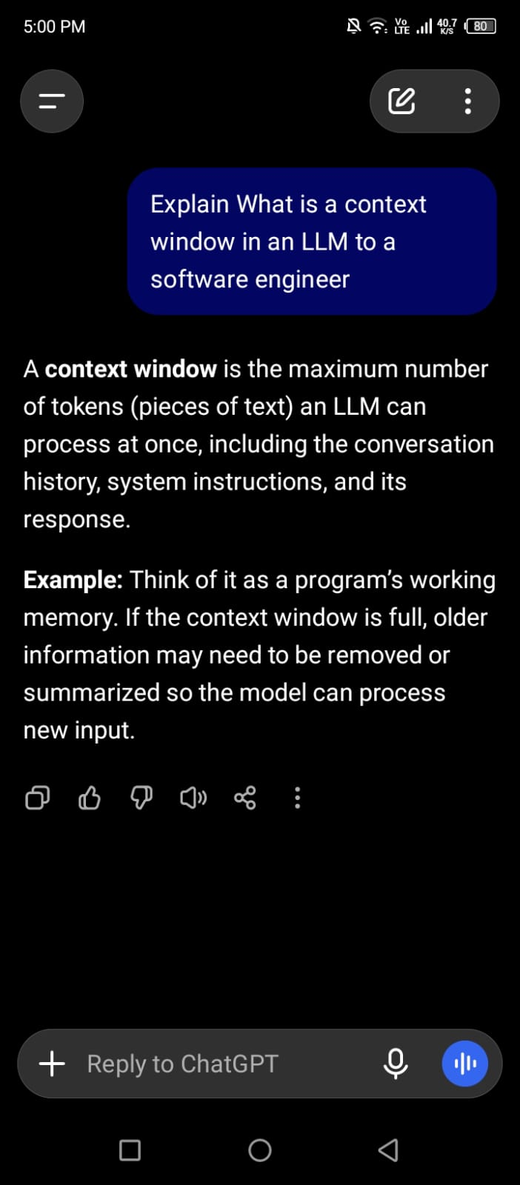
Prompt B: “Explain what a context window is in an LLM to a 10-year-old student.”
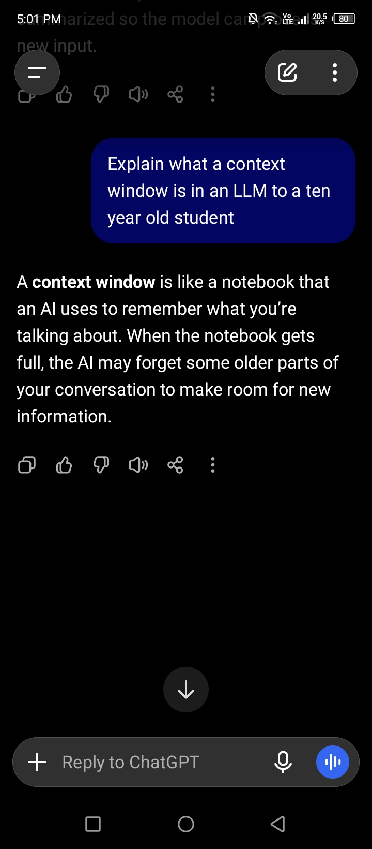

Observation: Both prompts asked about the same concept, but the responses were very different. Prompt A produced a technical answer that used terms such as tokens, input and output limits, and API requests. Prompt B produced a simpler answer built around an everyday comparison, such as a desk or a small notebook that can only hold so much at one time, and it avoided technical words.
Conclusion: The question stayed the same and only the instructions changed, yet the model adjusted its language, level of detail, and examples. This shows that the input given to an LLM strongly affects the output, which is why clear instructions matter when building AI applications.

8. Learning Summary
Today I learned that LLMs process text as tokens, that token usage affects cost and limits, and that the context window sets how much information a model can handle in one request. I also learned the difference between input and output, and the main limitations of LLMs, including mistakes and hallucinations. The experiment showed that changing the instructions changes the response. This understanding will help me when I start working with AI APIs, RAG systems, and AI agents.

9. Learning Resources
- OpenAI documentation: https://platform.openai.com/docs
- Google AI documentation: https://ai.google.dev/gemini-api/docs
- Hugging Face learning resources: https://huggingface.co/learn

